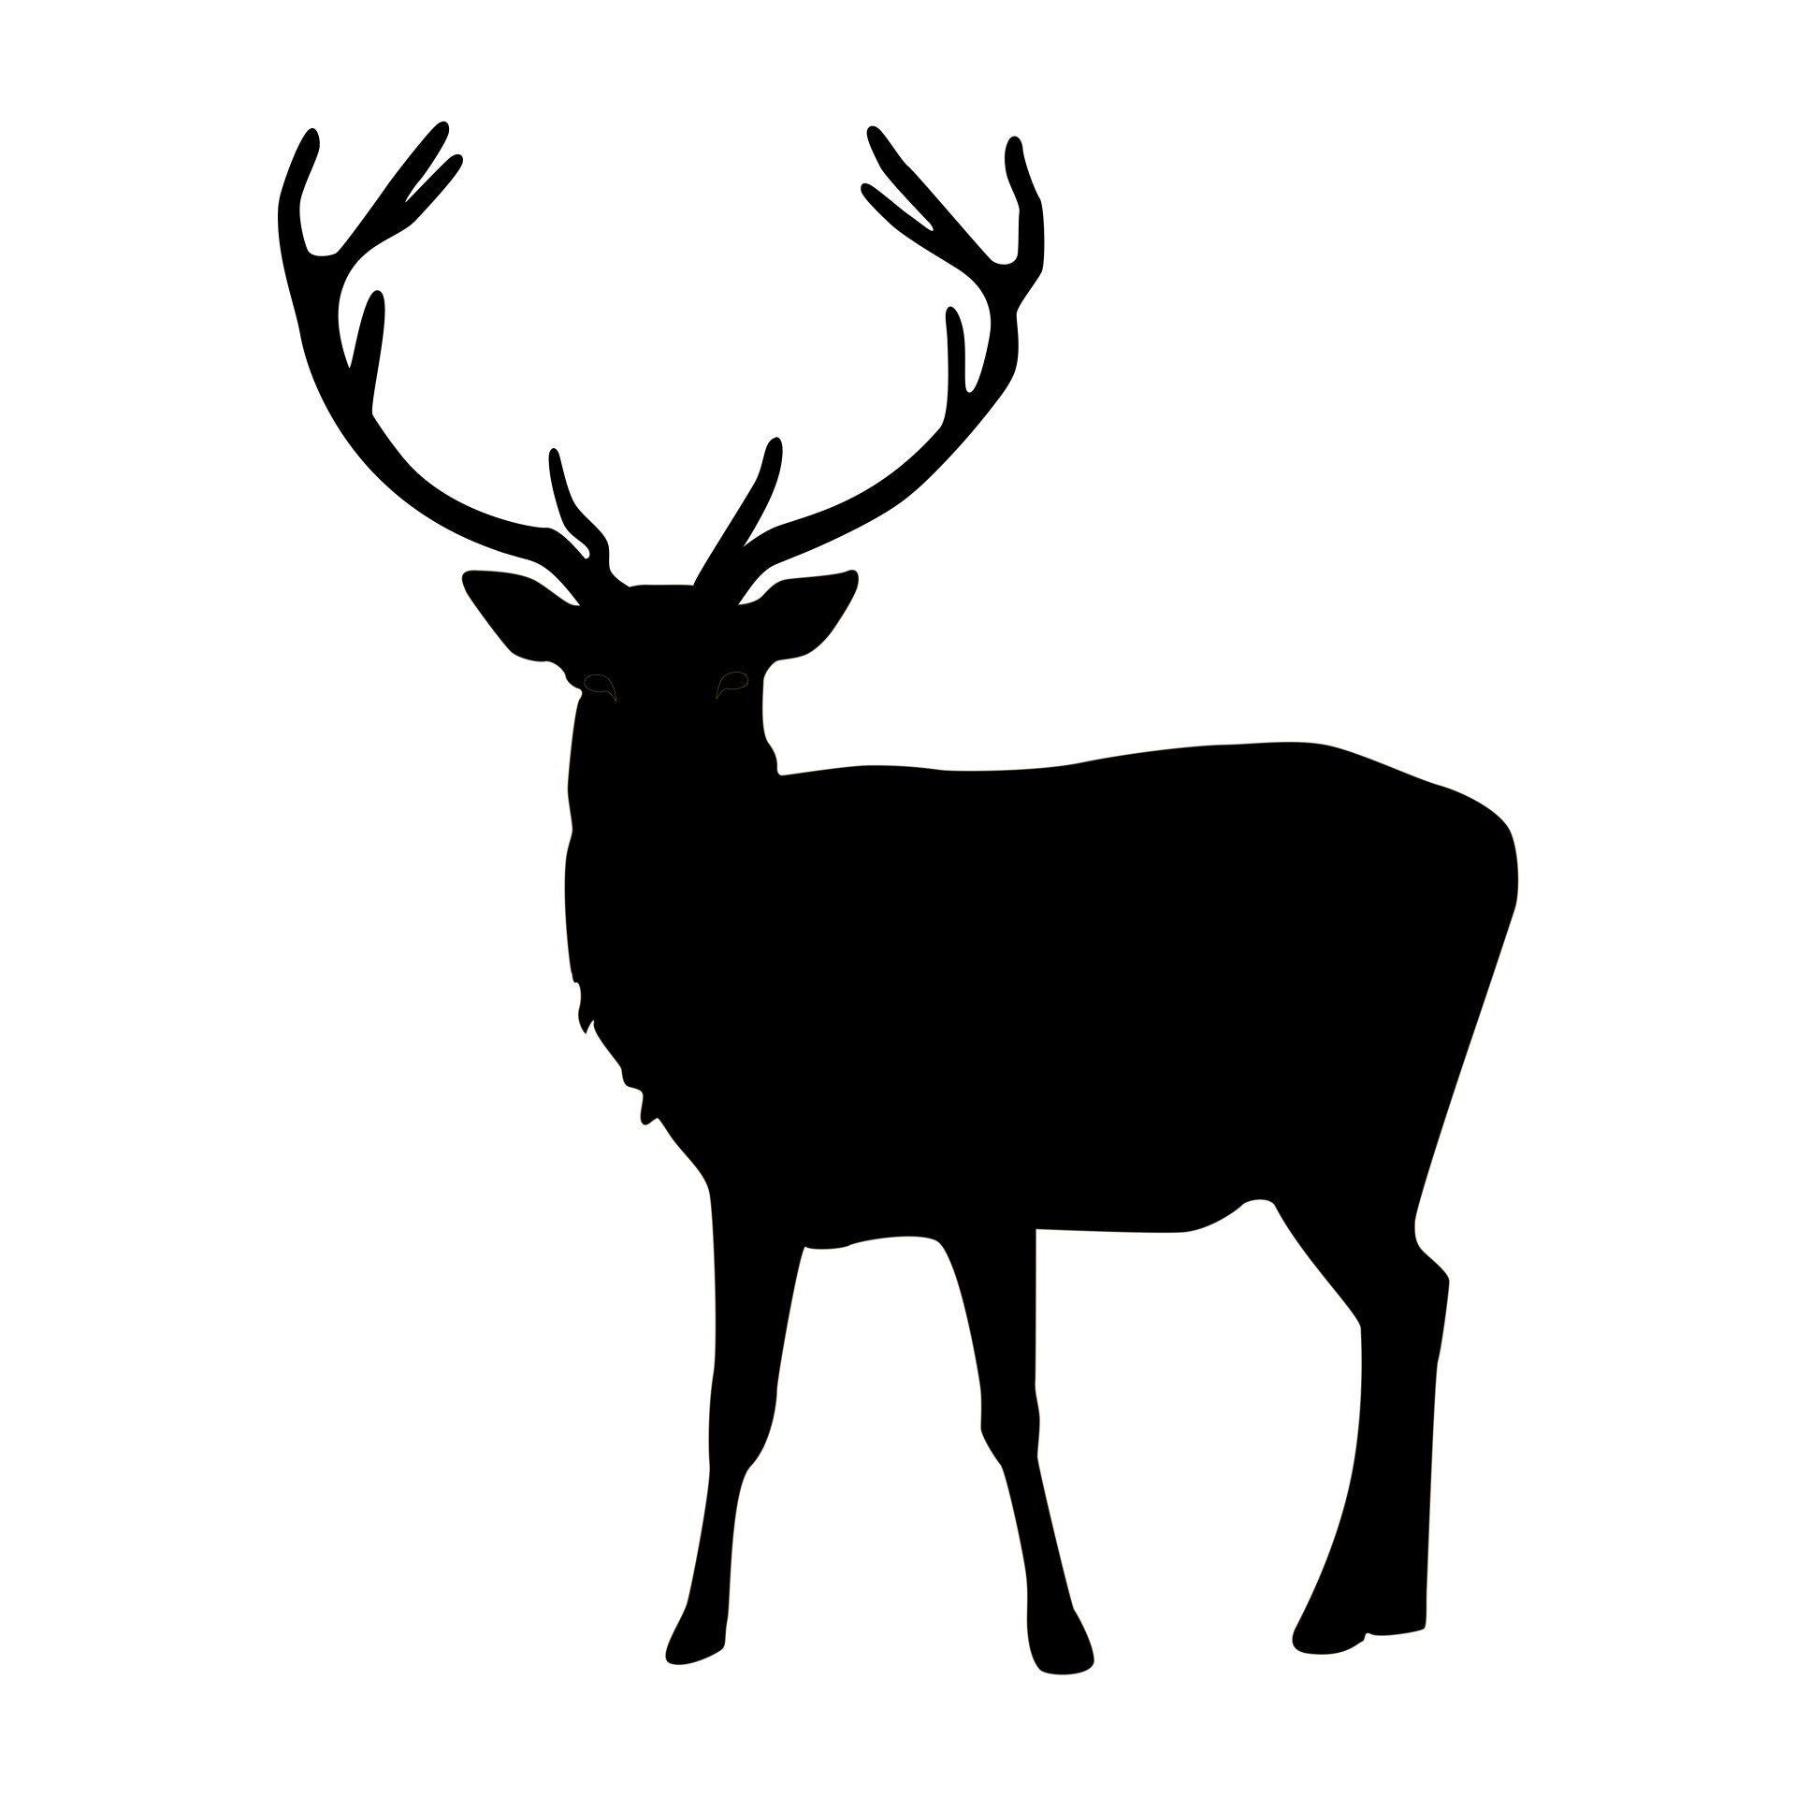
Wild Game Dinner

St. Pius Parish of Little Suamico is pleased to invite you to the 18th annual Wild Game Dinner & Auction.

This event will again be held in the Little Suamico church hall on Thursday, October 16, 2025, doors will open at 6:00 PM with dinner at 7:00 PM.

To obtain your ticket(s) please return the order form below no later than Friday, September 26, 2025.

Ticket sales are made on a first-come, first-served basis.
We will limit our seating to the first 80 people that respond.

Please don’t miss this opportunity to enjoy an evening of fellowship, fun, and food with so many friends and family from our community and beyond.

To make your reservation, please complete the ticket order form below and mail this form along with a check of $50.00 per ticket (payable to St. Pius Church) on or before September 26, 2025.

Your ticket(s) will be returned to you in the mail or given to you at church.

St. Pius Wild Game Dinner & Auction

Ticket Order Form

Your Ticket
Name: ________________________
Address:_______________________
______________________________
Phone#:_______________________
Guest Ticket (optional)
Name: _______________________
Address:______________________
_____________________________
Phone#:______________________

($50.00 per ticket – 2 tickets maximum, payable to St. Pius Church)
Contact Ann Tadisch at 920-366-2672 for mailing address

